Plotter for Callisto OVS-files

The Python tool 'Plott_OVS.py' allows plotting, zooming in- and out as well as saving the spectrum as a png-file from Callisto spectral overview.

**Requirements are:**1. Python 2.7 (from Anaconda) and Spyder for Python 2.7  
2. Spectral overview file(s) to plot

No editing of the script required unless you want to switch off grid and or you want to change label-sizes and/or tick-sizes and/or graphic format, e.g. jpg instead of png. Alternatively, change of y-unit (mV vs dB).

**Usage:**a) Either open Spyder and load the script Plott_OVS.py. Open a python console (no iPython!) and run the script by pressing function button *F5* or press green triangle at the top of Spyder.  
b) Or open a DOS-window, go the folder of the script and type *python Plott_OVS.py*.  
c) Or double click the batch file p.bat, which you may put as a link to your desktop.  
Once the script is running, you get a window to select a file as shown in figure 1.

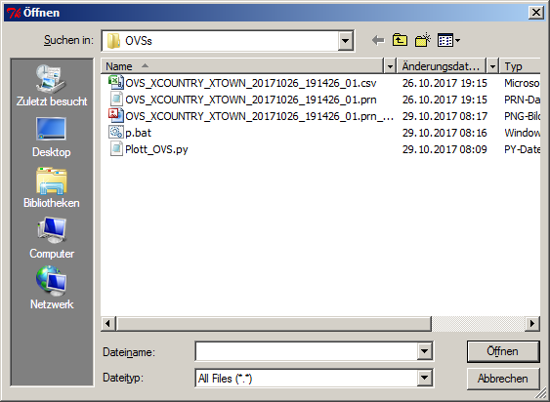

Fig 1: File-dialog to select spectral overview as prn or csv

Select a file you want to plot and within a seconds or even less you get the full size plot of the spectral overview with x-axis expressed in MHz and y-axis expressed in mV as the voltage of the analogue2digital converter or in dB, depending on variable db in the script. In case you want the plot in dB instead of mV, just change the variable db in the script to *True*.

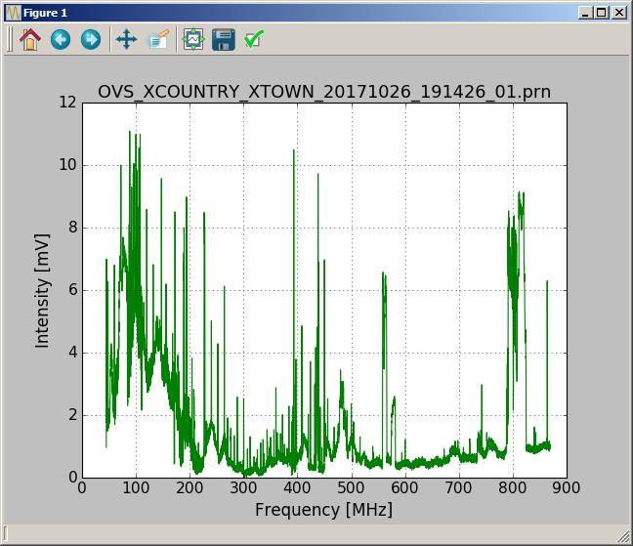

Fig. 2: Spectral overview in full size in case variable db is set to *True*.

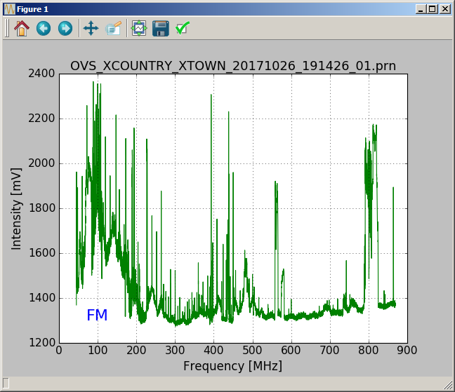

Fig. 3: The same as figure 2 but now as raw data, expressed in mV. Variable db=*False*.

At the top of this plot, there are 8 icons visible. The icon number 5 allows you to zoom in x and y, while the icon number 4 allows to move the plot inside the window. Icon 6 allows configuring subplots and icon number 7 allows you to save the plot in 9 different graphic formats. Icons 1, 2 and 3 allow changing views.

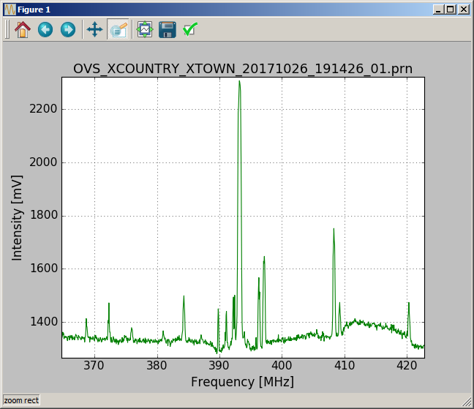

Fig. 4: Example of zooming in to TETRA, a international police information system.

File: Plotter for Callisto OVS.doc, version 0.1, 29.10.2017, Chr. Monstein